Chapter 8, Problem 57.

If the switch in Fig. 8.103 has been closed for a long time before t = 0 but is opened at t = 0, determine:

(a) the characteristic equation of the circuit,

(b) i_{x} and v_{R} for t > 0.

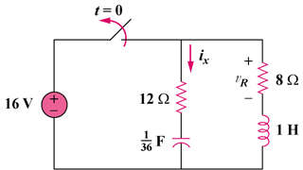

(1/36) F

Figure 8.103
For Prob. 8.57.

